Flow Diagram for Manual Price Reporting -CR

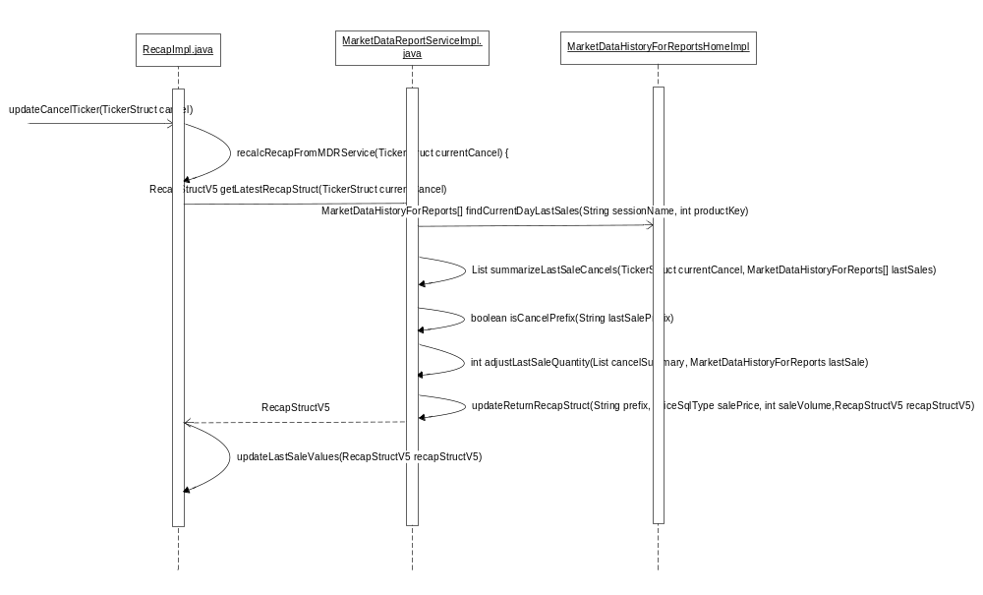

IDL Changes

Add new method to interface MarketDataReportService in server/idl/MarketDataReportService.idl
cmiMarketData :: RecapStruct getLatestRecapStruct(in cmiMarketData::TickerStruct currentCancel)
raises (
exceptions::SystemException,
exceptions::CommunicationException,
exceptions::DataValidationException,
exceptions::AuthorizationException
);

Update interface recapStructV5 to add following fields(in green colour) in cmi/idl/cmiMarketData.idl
struct RecapStructV5
{
RecapStruct recapStruct;
cmiUtil::DateTimeStruct lowPriceTime;
cmiUtil::DateTimeStruct highPriceTime;
cmiUtil::DateTimeStruct openingPriceTime;
RecapSuffix recapSuffix;
long lastSalePriceVolume;
long openPriceVolume;
long highPriceVolume;
long lowPriceVolume;
long numberOfTrades;

};

Java Changes

- MarketDataReportServiceImpl.java

Add new methods

- private List summarizeLastSaleCancels(TickerStruct currentCancel, MarketDataHistoryEntry[] lastSales)
- To Summaries price/quantity for all cancel entries

- private boolean isCancelPrefix(String lastSalePrefix)
- Determines if last sale prefix is one of the CANC,CNCO,CNCL,CNOL

- private int adjustLastSaleQuantity(List cancelSummary, MarketDataHistoryEntry lastSale)
- Calculates the quantity that should be used for this last sale based on summarized cancels.

- private void updateReturnRecapStruct(String prefix, PriceSqlType salePrice, int saleVolume,RecapStructV5 recapStructV5)
- Updates the last sale values in recap Struct

- public RecapStruct getLatestRecapStruct(TickerStruct currentCancel)
This method performs following functionalities.
- Call MarketDataHistoryForReportsHome.findCurrentDayLastSales(String sessionName, int productKey) to Search history for all last sale entries for the current day .
- Call summarizeLastSaleCancels(TickerStruct currentCancel, MarketDataHistoryEntry[] lastSales)
- Call isCancelPrefix(String lastSalePrefix)
- Call adjustLastSaleQuantity(List cancelSummary, MarketDataHistoryEntry lastSale)
- Call void updateReturnRecapStruct(String prefix, PriceSqlType salePrice, int saleVolume,RecapStructV5 recapStructV5)

- RecapImpl.java

Add members variables
private static boolean recalcRecapFromMDRService;

private static final String RECALC_RECAP_FROM_MDRS_SERVICE = "recalcRecapFromMDRService";

Add new methods
- private void recalcRecapFromMDRService(TickerStruct currentCancel)

This method get RecapStruct by calling getMarketDataReportService().getLatestRecapStruct(currentCancel);
Then call updateLastSaleValues(RecapStructV5 recapStructV5)

- public void updateLastSaleValues(RecapStructV5 recapStructV5)
This method is used to update the last sale values.

Modify methods

- private void updateCancelTicker(TickerStruct cancel)
To add last condition to check for flag recalcRecapFromMDRService

if (mustRecalcValues && recalcRecapFromMDRService)
{
recalcRecapFromMDRService(cancel);
}

New static block
To read property recalcRecapFromMDRService from SetMainContext script.

- MarketDataReportServiceHomeProxyImpl.java
Add member variable private int roundTripTimeoutValue;

Add new methods
- public void initialize()
To read roundTripTimeoutValue from MarketDataReportServcie.xml

Modify methods
- public MarketDataReportService find()
To get service using
(com.cboe.idl.businessServices.MarketDataReportService) ObjectResolver.resolveObject(responses[0].getObjectReference(),MarketDataReportServiceHelper.class.getName() , roundTripTimeoutValue);

- MarketDataReportServiceProxy.java
Add new methods
- public com.cboe.idl.cmiMarketData.RecapStructV5 getLatestRecapStruct(com.cboe.idl.cmiMarketData.TickerStruct param0)throws SystemException, CommunicationException,DataValidationException, AuthorizationException, NotFoundException
To delegates the request to MarketDataReportSerivce.

- MarketDtaReportServiceRoutingProxy.java

Add new methods

public com.cboe.idl.cmiMarketData.RecapStructV5 getLatestRecapStruct(com.cboe.idl.cmiMarketData.TickerStruct param0)
throws SystemException, CommunicationException,DataValidationException, AuthorizationException, NotFoundException
To delegates the request to MarketDataReportSerivce.

XML Changes

- MarketDataReportService.xml

Add follwing to to the section <GlobalMarketDataReportServiceHome>

<MarketDataReportServiceHomeProxyImplname="MarketDataReportServiceHomeProxyImplBC">
<MarketDataReportServiceHomeProxyImplProperties>
<roundTripTimeoutValue>10000</roundTripTimeoutValue>
</MarketDataReportServiceHomeProxyImplProperties>
</MarketDataReportServiceHomeProxyImpl>

<MarketDataReportServiceHomeProxyImplname="MarketDataReportServiceHomeProxyImplGlobal>
<MarketDataReportServiceHomeProxyImplProperties>
<roundTripTimeoutValue>0</roundTripTimeoutValue>
</MarketDataReportServiceHomeProxyImplProperties>
</MarketDataReportServiceHomeProxyImpl>

- TradeServcer.xml
Add the follwing part to section <BOContainer name="ProxyContainer">

<BOHome name="MarketDataReportServiceHome">
<BOHomeProperties>
<homeImpl>com.cboe.proxy.businessServices.MarketDataReportServiceHomeProxyImpl</homeImpl> <managedResourceName>MarketDataReportServiceHomeProxyImpl</managedResourceName>
</BOHomeProperties>
</BOHome>

- HybridTradeServer.xml
Add the follwing part to section <BOContainer name="ProxyContainer">

<BOHome name="MarketDataReportServiceHome">
<BOHomeProperties>
<homeImpl>com.cboe.proxy.businessServices.MarketDataReportServiceHomeProxyImpl</homeImpl> <managedResourceName>MarketDataReportServiceHomeProxyImpl</managedResourceName>
</BOHomeProperties>
</BOHome>

- extTradeServer.xml
Add the follwing part to section <BOContainer name="ProxyContainer">

<BOHome name="MarketDataReportServiceHome">
<BOHomeProperties>
<homeImpl>com.cboe.proxy.businessServices.MarketDataReportServiceHomeProxyImpl</homeImpl> <managedResourceName>MarketDataReportServiceHomeProxyImpl</managedResourceName>
</BOHomeProperties>
</BOHome>

- coppGlobalAdapter.xml
Add following part to the section
<BOContainer name="proxies"> <BOHomeProperties> <homeImp>

<managedResourceName>
MarketDataReportServiceHomeProxyImplGlobal
</managedResourceName>

Changes in .txt Files
server/properties/processes/
make entry of ${RUN_DIR}/properties/xml/MarketDataReportService.xml
in following files.

- TradeServer1Files.txt
- TradeServer2Files.txt
- TradeServer3iles.txt
- TradeServer4iles.txt
- HybridTradeServer1Files.txt
- ExtTradeServer1Files.txt

Scripts changes
setContext.main in Server/scripts/bin
make entry for recalcRecapFromMDRService=true after recalcRecapFromMDHistory=false.

DTD Changes
MarketDataReportService.dtd
Making entry for roundTripTimeoutValue

